

Data Technician

Name:
Course Date:
Table of contents
Day 1: Task 1 3
Day 1: Task 2 3
Day 3: Task 1 4
Day 4: Task 1: Written 6
Day 4: Task 2: SQL Practical 9
Course Notes 19
Additional Information 19

Day 1: Task 1

Please research and complete the below questions relating to key concepts of databases.

What is a primary key? | Primary key is the title of the field that uniquely identifies each row of data in a table. Example is customer ID which can be automatically indexed.
How does this differ from a secondary key? | A secondary key is not automatically indexed, but could form the basis for a second search, which is not the Primary key . Example, in a customer table, the primary key can be customer_ID, while a secondary key can be product_ID.
How are primary and foreign keys related? | In a table the first unique key is the primary key, any other key are classed as foreign keys. They could be primary keys for other tables in an ERD.
Provide a real-world example of a one-to-one relationship | Relationship between customers and passport is one to one. Each customer can have one passport and each passport belongs to one customer.
Provide a real-world example of a one-to-many relationship | A school has many pupils and pupils have just one school
Provide a real-world example of a many-to-many relationship | Students can have many lecturers and Each lecturer can have many students.

Day 1: Task 2

Please research and complete the below questions relating to key concepts of databases.

What is the difference between a relational and non-relational database? | Relational databases store structured data in tables with fixed schemas, ensuring strong consistency, ideal for complex queries but scale vertically. E.g SQL. They only use one computer system, once that is full they can’t take anymore information. They can’t handle big data.  Non-relational databases use flexible models (documents, key-value, graph) for diverse semi/unstructured data, large-scale data, prioritizing speed, scalability (horizontal), and availability over strict consistency. It suits evolving data needs E.g. NoSQL. It can process data from as many systems as you can connect.
What type of data would benefit off the non-relational model?  Why? | unstructured/semi-structured data, big data, real-time data, and rapidly changing requirements, benefiting from flexible schemas, horizontal scalability, and high performance for diverse types like JSON/XML, social media feeds, IoT streams.  NoSQL databases don't require a fixed schema, allowing data with diverse formats like different user profiles or product specs to coexist easily.  They scale horizontally (adding more servers) for massive data volumes and high traffic, ideal for big data and real-time needs.  By avoiding complex joins (denormalization), they offer faster read/write speeds for specific data patterns, crucial for high-velocity data.  Eg.MongoDB can be used for vector search through its built-in MongoDB Atlas Vector Search  Data replication across nodes ensures high availability, as the failure of one node doesn't bring the system down.  Diverse Data Models: Different NoSQL types (document, key-value, graph, column-family) are optimized for specific data structures (e.g., graphs for relationships, key-value for fast lookups)

Day 3: Task 1

Please research the below ‘JOIN’ types, explain what they are and provide an example of the types of data it would be used on.

Self-join | A JOIN clause is used to combine rows from two or more tables, based on a related column between them. Table is joined with itself, allowing the combination of data from a single table by creating a virtual copy of the table and establishing relationships between the original and virtual tables.  It is used for; Tracking changes in data, like version history or order tracking, by comparing records in the same table.  Performing recursive operations, like finding all descendants or ancestors of a particular record.  Example of data include hierarchical structures, such as organizational charts or category trees, to retrieve parent-child relationships.  Network or graph data  Syntax: SELECT column_name(s) FROM table1 T1, table1 T2 WHERE condition.
Right join | SQL right outer join combines all records from the right table and only matching rows from the left table. E.g. Orders and their customers (even unknown)
Full join | Returns all records when there is a match in either left or right table. E.g. Employees and departments (including unassigned)
Inner join | SQL inner join combines all rows that have matching values in two or more tables. E.g Orders and customers
Cross join | A CROSS JOIN combines every row from one table with every row from another table, resulting in all possible combinations of rows from both tables. It returns every combination of rows from the two participating tables. If the first table has 10 rows and the second has 5, the result of the CROSS JOIN will contain 50 rows. E.g. Product variants (e.g., sizes × colors).  SELECT [column names]  FROM [TableA]  CROSS JOIN [TableB]
Left join | All matches and unmatched from left table.  e.g Customers and all their orders (even none)

Day 4: Task 1: Written

In your groups, discuss and complete the below activity. You can either nominate one writer or split the elements between you. Everyone however must have the completed work below:

Imagine you have been hired by a small retail business that wants to streamline its operations by creating a new database system. This database will be used to manage inventory, sales, and customer information. The business is a small corner shop that sells a range of groceries and domestic products. It might help to picture your local convenience store and think of what they sell. They also have a loyalty program, which you will need to consider when deciding what tables to create.

Write a 500-word essay explaining the steps you would take to set up and create this database. Your essay should cover the following points:
- Understanding the Business Requirements:
  - What kind of data will the database need to store?
  - Who will be the users of the database, and what will they need to accomplish?
- Designing the Database Schema:
  - How would you structure the database tables to efficiently store inventory, sales, and customer information?
  - What relationships between tables are necessary (e.g., how sales relate to inventory and customers)?
- Implementing the Database:
  - What SQL commands would you use to create the database and its tables?
  - Provide examples of SQL statements for creating tables and defining relationships between them.
- Populating the Database:
  - How would you input initial data into the database? Give examples of SQL INSERT statements.
- Maintaining the Database:
  - What measures would you take to ensure the database remains accurate and up to date?
  - How would you handle backups and data security?

Your essay should include specific examples of SQL commands and explain why each step is necessary for creating a functional and efficient database for the retail business.

Please write your 500-word essay here | Understanding the Business Requirements:  - What kind of data will the database need to store?  Designing a database for a small retail business begins with understanding its needs. The database should store inventory information (product names, categories, stock levels, prices), sales (dates, quantities, totals, and payment methods), and customer information, including loyalty program details such as names, contact information, membership IDs, points, and purchase history.  To meet these needs, three tables can be created: Inventory for product details, Sales to record transactions linking products and customers, and Customers to manage personal and loyalty information.  - Who will be the users of the database, and what will they need to accomplish?  The main users are store staff: cashiers need to process sales efficiently, inventory managers monitor stock levels and reorder products, and the owner requires reports on sales, inventory, and customer activity to make informed decisions.  2. Designing the Database Schema  Figure 1: Corner_Shop ERD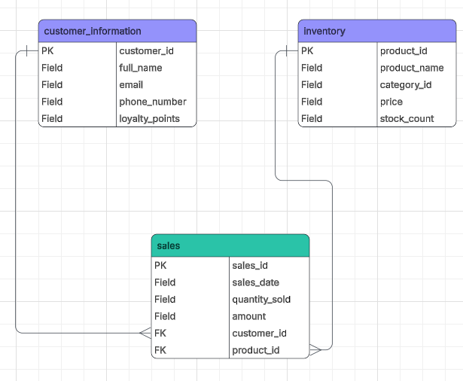  Above is the schema used for our database design. There are 3 entity tables which are named “sales”, “inventory” and “customer_inventory”, customer_information’s primary key is customer_id in the sales table as foreign key and the inventory’s primary key is product_id in the sales table as a foreign key.  3. Implementing the Database  The implementation process begins by establishing the database environment using the CREATE DATABASE command. Once the database is set up, the tables are created to organize the data efficiently. The independent tables are created first to store core information like customer details and inventory, utilizing specific data types and constraints to ensure accuracy. Finally, the transaction table is established. This table uses Foreign Keys to link back to the independent tables, creating a relational structure that ensures every sale is correctly associated with a specific customer and product.  CREATE DATABASE CornerShopDB;  USE CornerShopDB;  CREATE TABLE customer_information (  customer_id INT AUTO_INCREMENT PRIMARY KEY,  full_name VARCHAR(100) NOT NULL,  email VARCHAR(100) NOT NULL,  phone_number VARCHAR(15),  loyalty_points INT DEFAULT 0  );  CREATE TABLE inventory (  product_id INT AUTO_INCREMENT PRIMARY KEY,  product_name VARCHAR(100) NOT NULL,  category_id INT,  price DECIMAL(10, 2) NOT NULL,  stock_count INT DEFAULT 0  );  CREATE TABLE sales (  sale_id INT AUTO_INCREMENT PRIMARY KEY,  sale_date DATETIME DEFAULT CURRENT_TIMESTAMP,  quantity_sold INT NOT NULL,  amount DECIMAL(10, 2) NOT NULL,  customer_id INT,  product_id INT,  FOREIGN KEY (customer_id) REFERENCES customer_information(customer_id),  FOREIGN KEY (product_id) REFERENCES inventory(product_id)  );  2B DESIGNING DATABASE SCHEMA  The database establishes logical connections between customers and sales and inventory and the loyalty program. A customer can make multiple purchases. The sale records all products that were sold together with their respective quantities. The system automatically decreases product stock levels after a sale because it needs to maintain accurate inventory records. The shop tracks inventory products to maintain constant knowledge of available stock levels. Customers who join the loyalty programme are linked to a loyalty account which records points earned or used during purchases allowing the shop to track rewards accurately.  Q4:  Using the table relationships as a guide, I added data to the database in a logical order. In order for each sale to use a legitimate customer_id, I first added customer records. After that, I added inventory information to make sure every product was there before it was connected to sales. Lastly, I connected each transaction to a customer and a product by adding sales records. This method guarantees consistency in stock levels, sales totals, and loyalty points while also preserving referential integrity.  INSERT INTO customer_information  (customer_id, full_name, email, phone_number, loyalty_points)  VALUES  (1, 'Amina Khan', 'amina.khan@email.com', '07123456789', 120),  (2, 'Tom Baker', 'tom.baker@email.com', '07987654321', 40);  INSERT INTO inventory  (product_id, product_name, category_id, price, stock_count)  VALUES  (101, 'Basmati Rice 1kg', 1, 2.49, 15),  (102, 'Washing Up Liquid 500ml', 2, 1.29, 30),  (103, 'Milk 2L', 1, 1.65, 24);  INSERT INTO sales  (sales_id, sales_date, quantity_sold, amount, customer_id, product_id)  VALUES  (5001, '2026-02-05', 2, 4.98, 1, 101),  (5002, '2026-02-05', 1, 1.29, 2, 102),  (5003, '2026-02-05', 1, 1.65, 1, 103);  Q5:  a. What measures would you take to ensure the database remains accurate and up to date?  Automation, reduce manual input with enforce standardized data entry rules, implement automated validation during entry, conduct regular audits and cleansing, establish clear data governance policies. Proactive monitoring and prompt correction of issues are key to preventing data decay.  provide staff training, and build in feedback loops for continuous improvement.  b. How would you handle backups and data security  Backup policy- Daily/weekly? Local backups (external drives), Cloud backups, Hybrid solutions that combine both  Enable multi-factor authentication.  Encryption, Encrypt all sensitive data.  User access controls, Regular vulnerability assessments, Secure data storage and transfer  Use automated and encrypted backups, and educate employees on security best practices.  Limit access with role-based permissions.  Regularly test and audit security systems

Day 4: Task 2: SQL Practical

In your groups, work together to answer the below questions. It may be of benefit if one of you shares your screen with the group and as a team answer / take screen shots from there.

Setting up the database:

- Download world_db(1)
- Follow each step to create your database

For each question I would like to see both the syntax used and the output.

- Count Cities in USA: Scenario: You've been tasked with conducting a demographic analysis of cities in the United States. Your first step is to determine the total number of cities within the country to provide a baseline for further analysis.

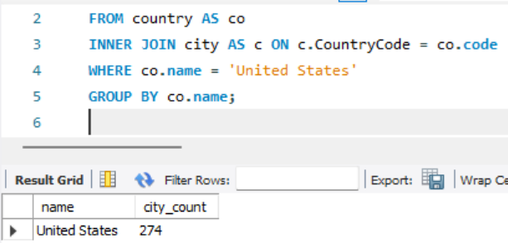

- Country with Highest Life Expectancy: Scenario: As part of a global health initiative, you've been assigned to identify the country with the highest life expectancy. This information will be crucial for prioritising healthcare resources and interventions.

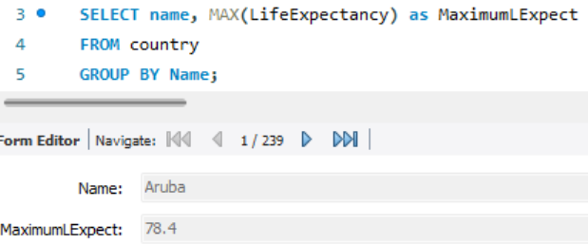

- "New Year Promotion: Featuring Cities with 'New : Scenario: In anticipation of the upcoming New Year, your travel agency is gearing up for a special promotion featuring cities with names including the word 'New'. You're tasked with swiftly compiling a list of all cities from around the world. This curated selection will be essential in creating promotional materials and enticing travellers with exciting destinations to kick off the New Year in style.

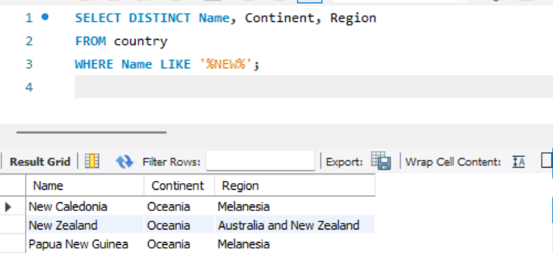

- Display Columns with Limit (First 10 Rows): Scenario: You're tasked with providing a brief overview of the most populous cities in the world. To keep the report concise, you're instructed to list only the first 10 cities by population from the database.

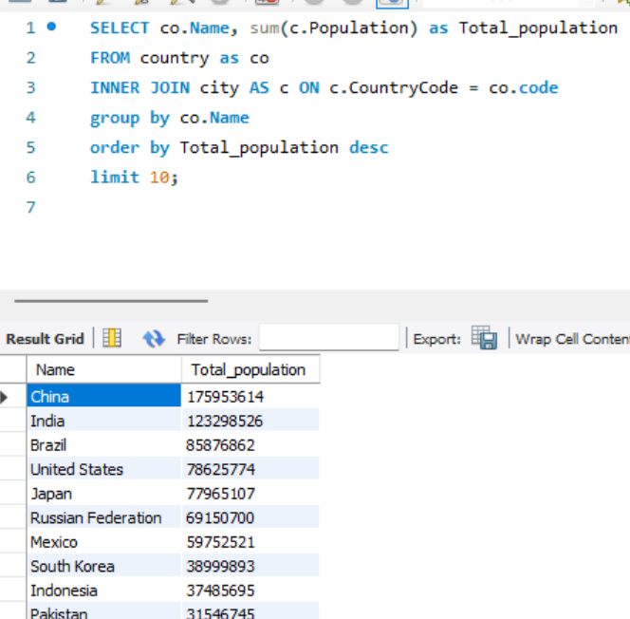

- Cities with Population Larger than 2,000,000: Scenario: A real estate developer is interested in cities with substantial population sizes for potential investment opportunities. You're tasked with identifying cities from the database with populations exceeding 2 million to focus their research efforts.

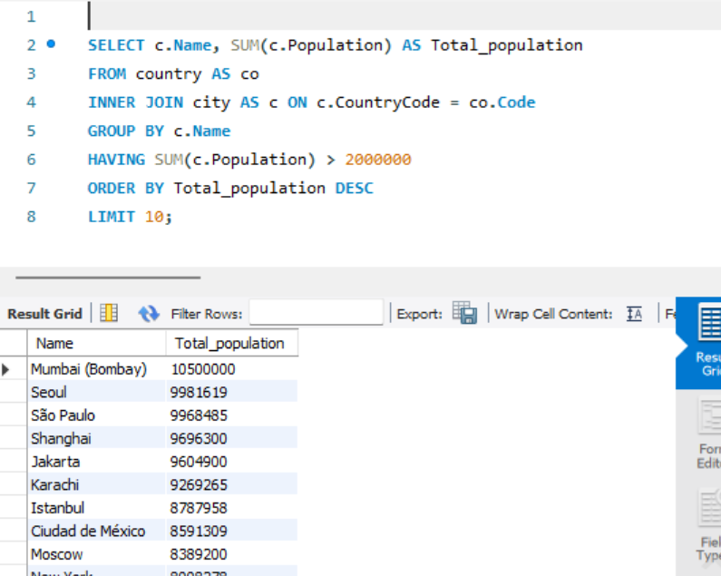

- Cities Beginning with 'Be' Prefix: Scenario: A travel blogger is planning a series of articles featuring cities with unique names. You're tasked with compiling a list of cities from the database that start with the prefix 'Be' to assist in the blogger's content creation process.

- Cities with Population Between 500,000-1,000,000: Scenario: An urban planning committee needs to identify mid-sized cities suitable for infrastructure development projects. You're tasked with identifying cities with populations ranging between 500,000 and 1 million to inform their decision-making process.

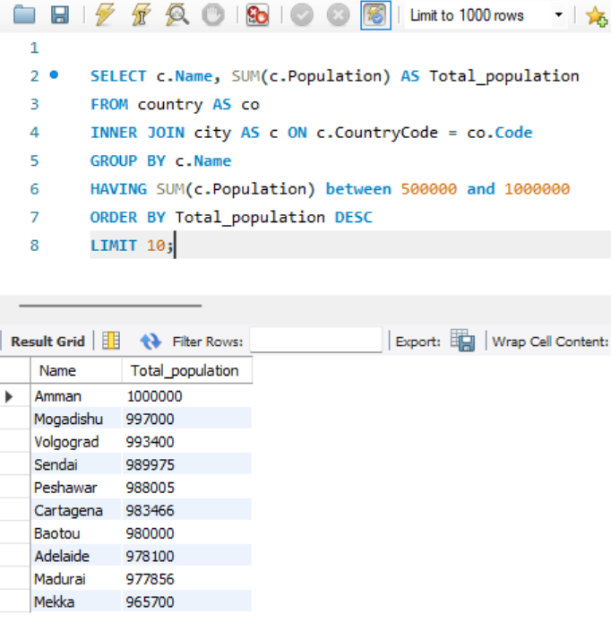

- Display Cities Sorted by Name in Ascending Order: Scenario: A geography teacher is preparing a lesson on alphabetical order using city names. You're tasked with providing a sorted list of cities from the database in ascending order by name to support the lesson plan.

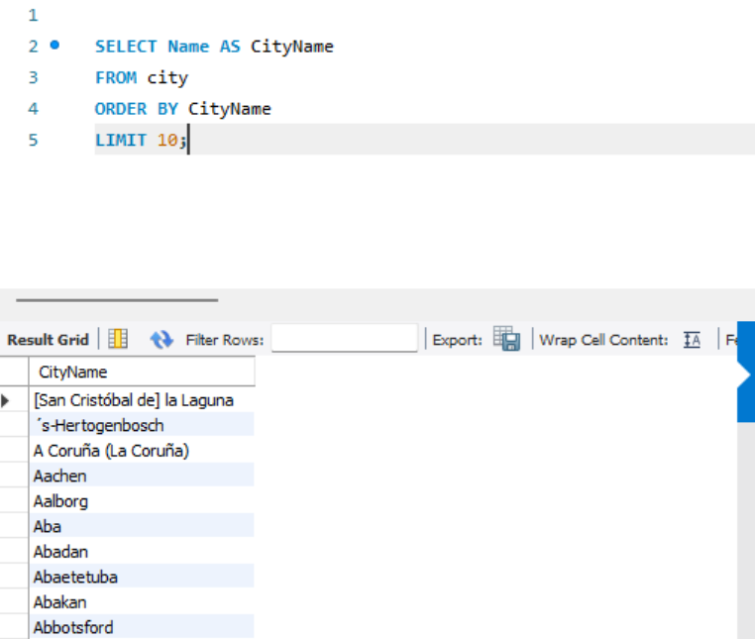

- Most Populated City: Scenario: A real estate investment firm is interested in cities with significant population densities for potential development projects. You're tasked with identifying the most populated city from the database to guide their investment decisions and strategic planning.

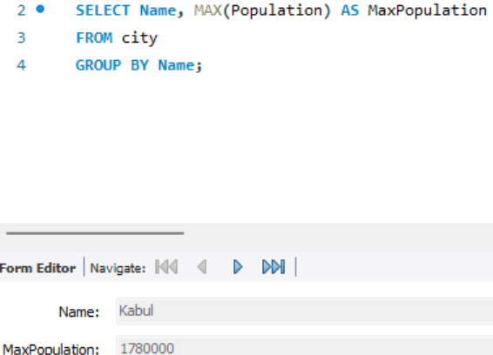

- City Name Frequency Analysis: Supporting Geography Education Scenario: In a geography class, students are learning about the distribution of city names around the world. The teacher, in preparation for a lesson on city name frequencies, wants to provide students with a list of unique city names sorted alphabetically, along with their respective counts of occurrences in the database. You're tasked with this sorted list to support the geography teacher.

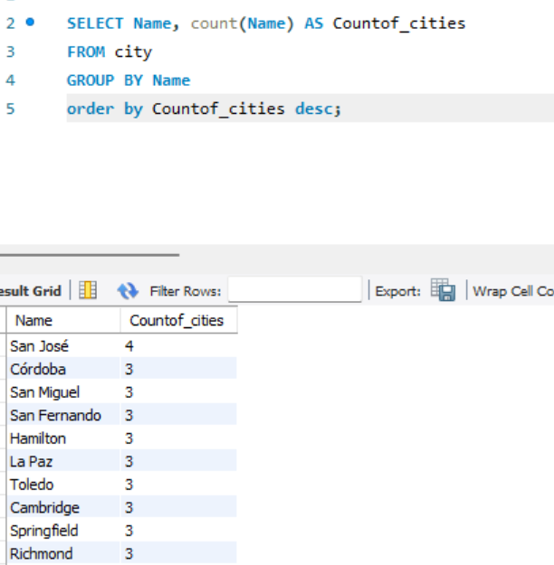

- City with the Lowest Population: Scenario: A census bureau is conducting an analysis of urban population distribution. You're tasked with identifying the city with the lowest population from the database to provide a comprehensive overview of demographic trends.

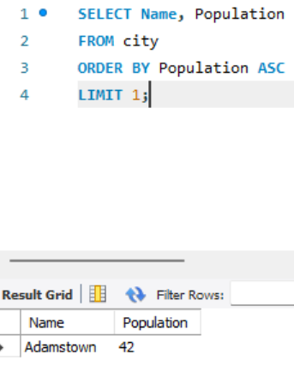

- Country with Largest Population: Scenario: A global economic research institute requires data on countries with the largest populations for a comprehensive analysis. You're tasked with identifying the country with the highest population from the database to provide valuable insights into demographic trends.

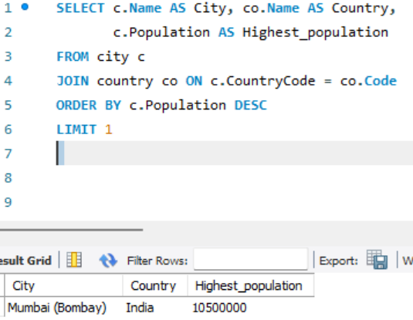

- Capital of Spain: Scenario: A travel agency is organising tours across Europe and needs accurate information on capital cities. You're tasked with identifying the capital of Spain from the database to ensure itinerary accuracy and provide travellers with essential destination information.

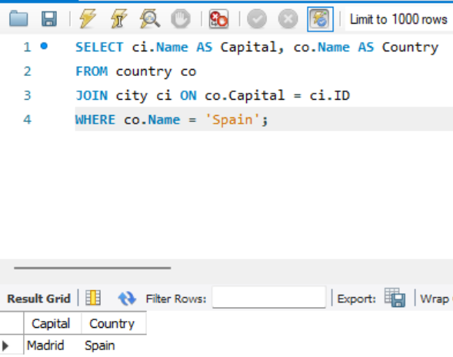

- Country with Shortest Life Expectancy: Scenario: A healthcare foundation is conducting research on global health indicators. You're tasked with identifying the country with the lowest life expectancy from the database to inform their efforts in improving healthcare systems and policies.

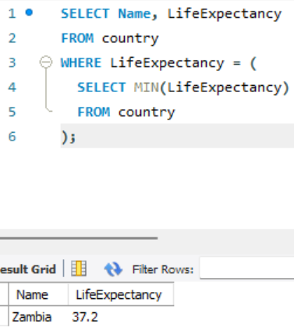

- Cities in Europe: Scenario: A European cultural exchange program is seeking to connect students with cities across the continent. You're tasked with compiling a list of cities located in Europe from the database to facilitate program planning and student engagement.
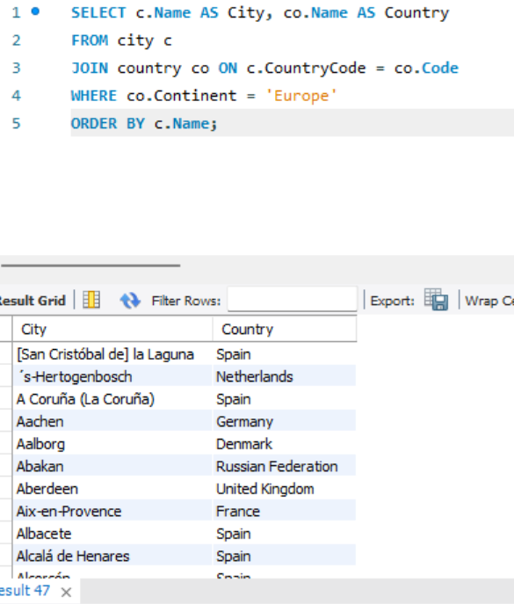

- Average Population by Country: Scenario: A demographic research team is conducting a comparative analysis of population distributions across countries. You're tasked with calculating the average population for each country from the database to provide valuable insights into global population trends.

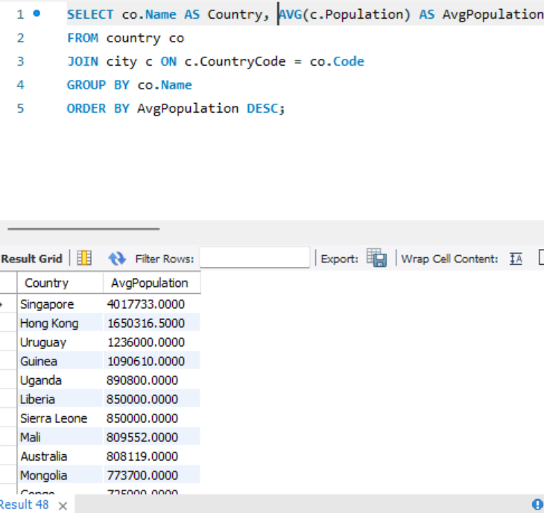

- Capital Cities Population Comparison: Scenario: A statistical analysis firm is examining population distributions between capital cities worldwide. You're tasked with comparing the populations of capital cities from different countries to identify trends and patterns in urban demographics.

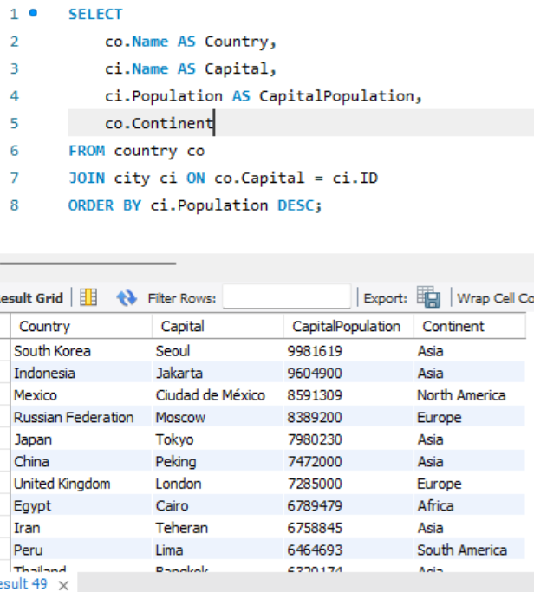

- Countries with Low Population Density: Scenario: An agricultural research institute is studying countries with low population densities for potential agricultural development projects. You're tasked with identifying countries with sparse populations from the database to support the institute's research efforts.

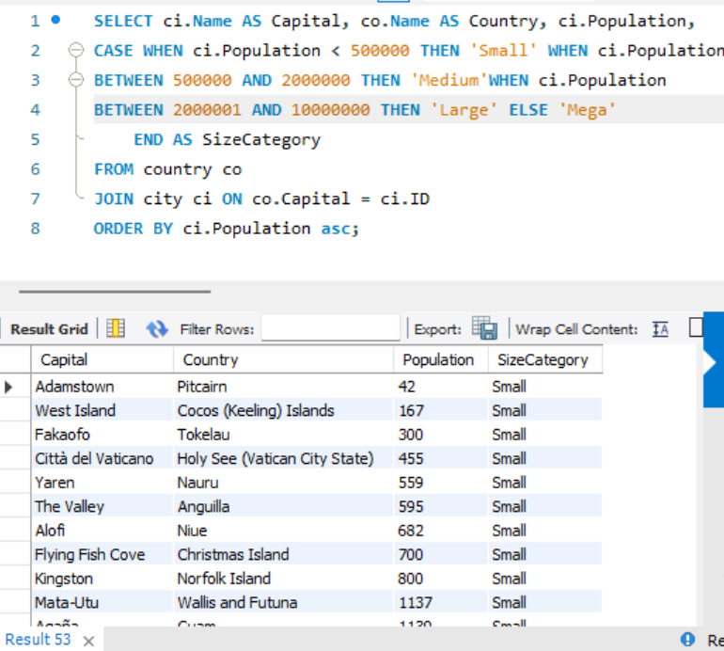

- Cities with High GDP per Capita: Scenario: An economic consulting firm is analysing cities with high GDP per capita for investment opportunities. You're tasked with identifying cities with above-average GDP per capita from the database to assist the firm in identifying potential investment destinations.

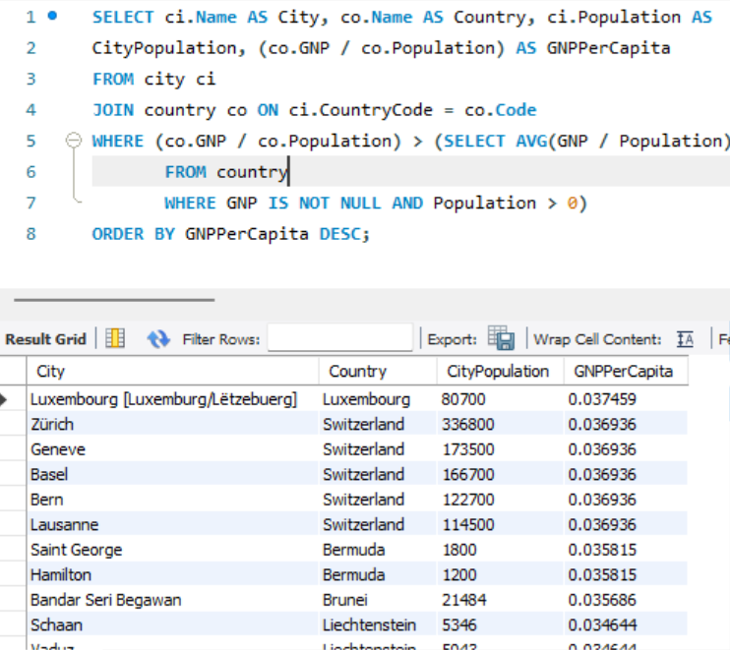

- Display Columns with Limit (Rows 31-40): Scenario: A market research firm requires detailed information on cities beyond the top rankings for a comprehensive analysis. You're tasked with providing data on cities ranked between 31st and 40th by population to ensure a thorough understanding of urban demographics.

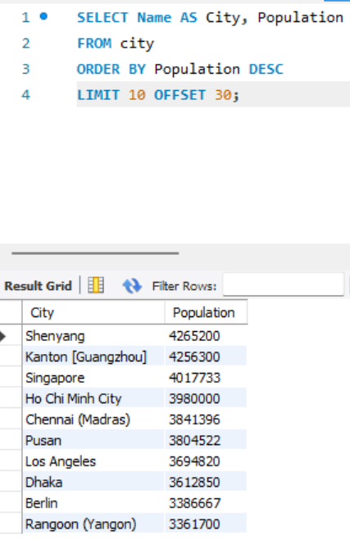

Course Notes

It is recommended to take notes from the course, use the space below to do so, or use the revision guide shared with the class:

Additional Information

We have included a range of additional links to further resources and information that you may find useful, these can be found within your revision guide.

END OF WORKBOOK

Please check through your work thoroughly before submitting and update the table of contents if required.

Please send your completed work booklet to your trainer.

